**Website correction – 1**

1. **Logo : its upper side is not showing properly…..looks like half cut……. Please make it correct**
2. **Do - About US - in single line**
3. **Remove Apply IDO and it with - Login**
4. **Mx Million Metaverse DAO -**

**Building a Future, Bridging Realities & Nurturing wealth**

1. **Buy MXMDAO Token**

**Website Correction -2**

1. **Remove Dots or manage with below point 2**
2. **Change these words with**
3. **Virtual City**
4. **DAO Governance**
5. **Future Of Advertising**
6. **NFT Marketplace**
7. **Play2Earn Games**
8. **Farm To Fortune**
9. **Virtual Events Platform**
10. **Virtual Dating Platform**
11. **Change the image – Girl with VR** 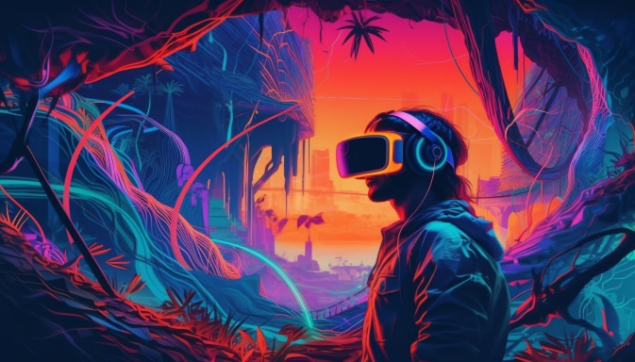

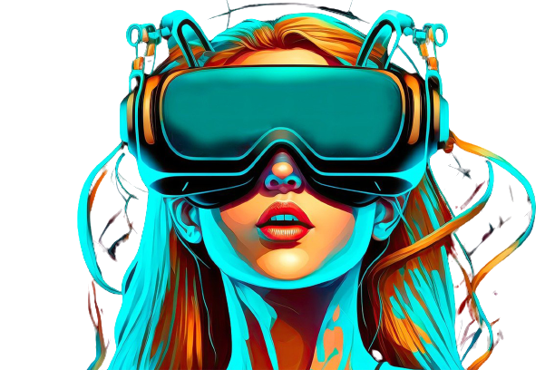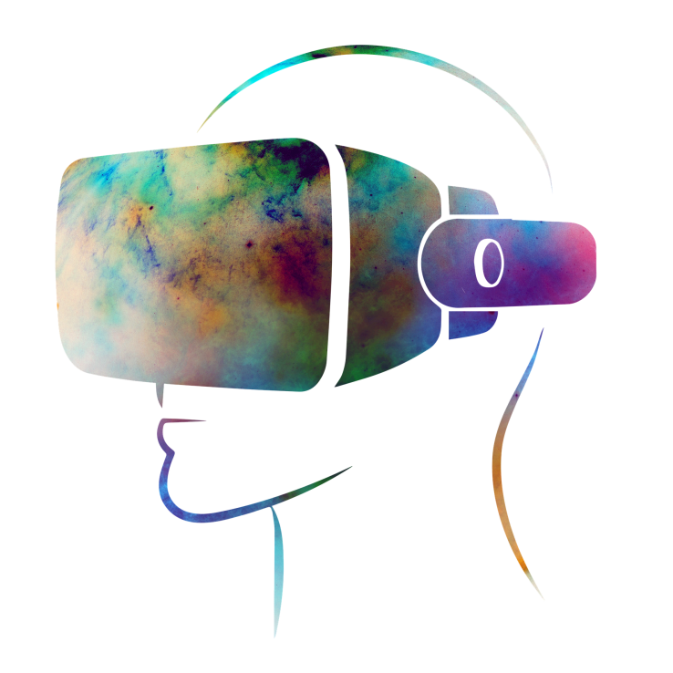

1. **ABOUT US**

**Bridging Realities with Innovative Assets**

**MxMillion Metaverse DAO is a pioneering venture at the forefront of the metaverse revolution. It's a dynamic platform that brings together the tangible and the digital in a way never seen before. At its heart, MxMillion connects real-world assets with the versatility of NFTs (Non-Fungible Tokens) and the power of cryptocurrency, redefining the concept of ownership in the digital age. Our mission is to empower users worldwide, providing them with the opportunity to not only own but actively manage digital assets while reaping rewarding benefits.**

**In essence, MxMillion Metaverse DAO seeks to empower users worldwide by providing them with the means to not only own but also actively manage digital assets within the metaverse. This approach aligns with the evolving landscape of virtual reality, blockchain technology, and the growing desire for individuals to engage with digital ecosystems in a meaningful and productive manner. As the metaverse continues to evolve,**

**Amidst this transformative landscape, MxMillion Metaverse DAO stands as a pioneering force. This innovative project envisions a metaverse ecosystem like no other, aiming to seamlessly bridge the gap between real-world assets and the digital realm. MxMillion Metaverse DAO recognizes the importance of this fusion in creating a truly immersive and meaningful metaverse experience.**

1. **Add Discord Logo in this**

**Website Correction – 3**

**Unique Features:**

**1. Real-World Assets Linked NFTs:**

**MxMillion introduces the world's first fusion of real-world assets with NFTs. This groundbreaking feature allows users to own and trade digital representations of tangible assets, adding a layer of authenticity and value to the metaverse.**

**2. Crypto Currency Integration:**

**In the MxMillion ecosystem, cryptocurrency plays a central role. Users can seamlessly transact, invest, and earn rewards through a native digital currency, fostering financial growth within the metaverse.**

**3. Farm to Fortune:**

**We emphasize the virtual farming concept as a core feature, allowing users to cultivate and trade virtual crops backed by NFTs, turning their virtual farms into sources of real wealth. We've gamified the farming experience with interactive gameplay elements, making asset management engaging and entertaining.**

**4. Virtual City:**

**Our comprehensive metaverse city offers a diverse array of environments and activities, providing an immersive experience for all users.**

**5. Metaverse Play2Earn Games:**

**Mx Million Metaverse offers different kind of play2earn games for youth and families,**

**6. Cross-Metaverse Integration:**

**MxMillion Metaverse DAO is poised to explore partnerships with other metaverse projects, enabling seamless cross-metaverse interactions and expanding horizons.**

**7. Harvesting Real-World Assets with Cryptocurrency**

**Our innovative "Proof of Stock" model seamlessly integrates real-world assets, such as physical stocks, with blockchain technology. This pioneering approach allows individuals to tokenize ownership of traditional assets, providing the benefits of decentralization and a transparent ledger system. Below, you will find a detailed outline of a project utilizing the Proof of Stock model, bridging the realms of the physical and the digital to nurture wealth and innovation.**

**8. The Future of Advertising: Blurring Realities with 3D Billboards:**

**As we step into the metaverse, the future of advertising undergoes a profound transformation, bridging the boundaries between virtual and physical worlds. In this evolving landscape, 3D billboards emerge as a captivating force, not confined to the metaverse alone but extending into our tangible reality.**

**Within the metaverse, 3D billboards redefine advertising's potential. These immersive structures seamlessly blend into virtual environments, capturing users' attention with interactive and dynamic content. Advertisers can engage audiences through personalized experiences, fostering deeper connections between brands and consumers.**

**9. DAO's Governance:**

**MxMillion Metaverse DAO employs a decentralized autonomous organization (DAO) governance model, empowering the community to participate in decision-making and shape the future of the platform.**

**MxMillion Metaverse DAO's governance model ensures that key decisions, such as platform upgrades, investments, and changes, are collectively determined by the community of token holders. This democratic approach aligns the project's direction with the interests of its stakeholders, fostering transparency and trust within the ecosystem.**

**10. NFT Marketplace**

**Our platform hosts a vibrant marketplace where users can trade a diverse range of assets, including land, cash crops, and other virtual commodities. Where user can mint, stake, buy/sell NFTs anytime anywhere.**